DESIGN AND VERIFICATION OF SERIAL PERIPHERAL INTERFACE(SPI) PROTOCOL IN VERILOG

Submitted by-
Swarnaprava Nanda (ECE,7thsem,regd.1721209017)
Manoj Kumar Nayak (ECE,7thsem,regd.1721209019 )

Guided by-
Dr. Saroj Rout

ABSTRACT- In this project we designed, a Serial Peripheral Interface (SPI) for a 32 byte Static Random Access Memory (SRAM) using Verilog code which can be used as a low power consuming device by integrating with Microcontrollers (MCUs) and peripheral ICs, for example IOT sensors.

INTRODUCTION
Serial peripheral interface (SPI) is one of the most widely used interfaces between microcontroller and peripheral ICs such as sensors, ADCs, DACs, shift registers. It uses separate clock and data lines, along with a select line to choose the device you wish to talk to. SPI uses separate lines for data and a "clock" that keeps both sides in perfect sync. The clock is an oscillating signal that tells the receiver exactly when to sample the bits on the data line. This could be the rising (low to high) or falling (high to low) edge of the clock signal. In SPI protocol, the devices are connected in a Master – Slave relationship in a multi – point interface. In this type of interface, one device is considered the Master of the bus (usually a Microcontroller) and all the other devices (peripheral ICs or even other Microcontrollers) are considered as slaves. In SPI protocol, there can be only one master but many slave devices.

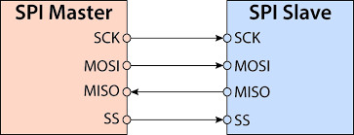

Fig1.Physical layer of SPI

The SPI bus consists of 4 signals or pins:
i. Master Out Slave In (MOSI) — Carries data out of Master to Slave.
ii. Master In Slave Out (MISO) — Carries data from Slave to master.
iii. Slave Select/Chip Select (CS) – Unique line to select a slave.
iv. SCLK—Master produced clock to synchronize data transfer MOSI.

2. Modes in SPI

Depending on the values of Clock Polarity (CPOL) and Clock Phase (CPHA), there are 4 modes of operation of SPI: Modes 0 to 3.

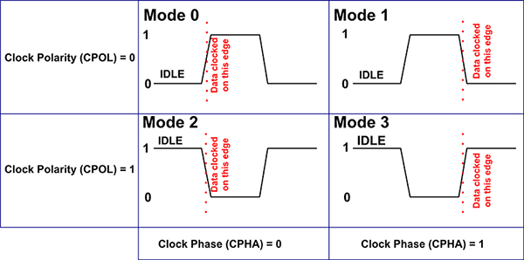

Fig2.Modes of operation

Mode 3 occurs when Clock Polarity is HIGH and Clock Phase is 1 (CPOL = 1 and CPHA = 1). During Mode 3, data transmission occurs during rising edge of the clock.

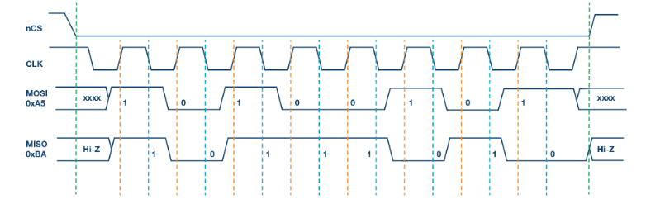

Fig3. : Timing diagram in Mode-3 of SPI

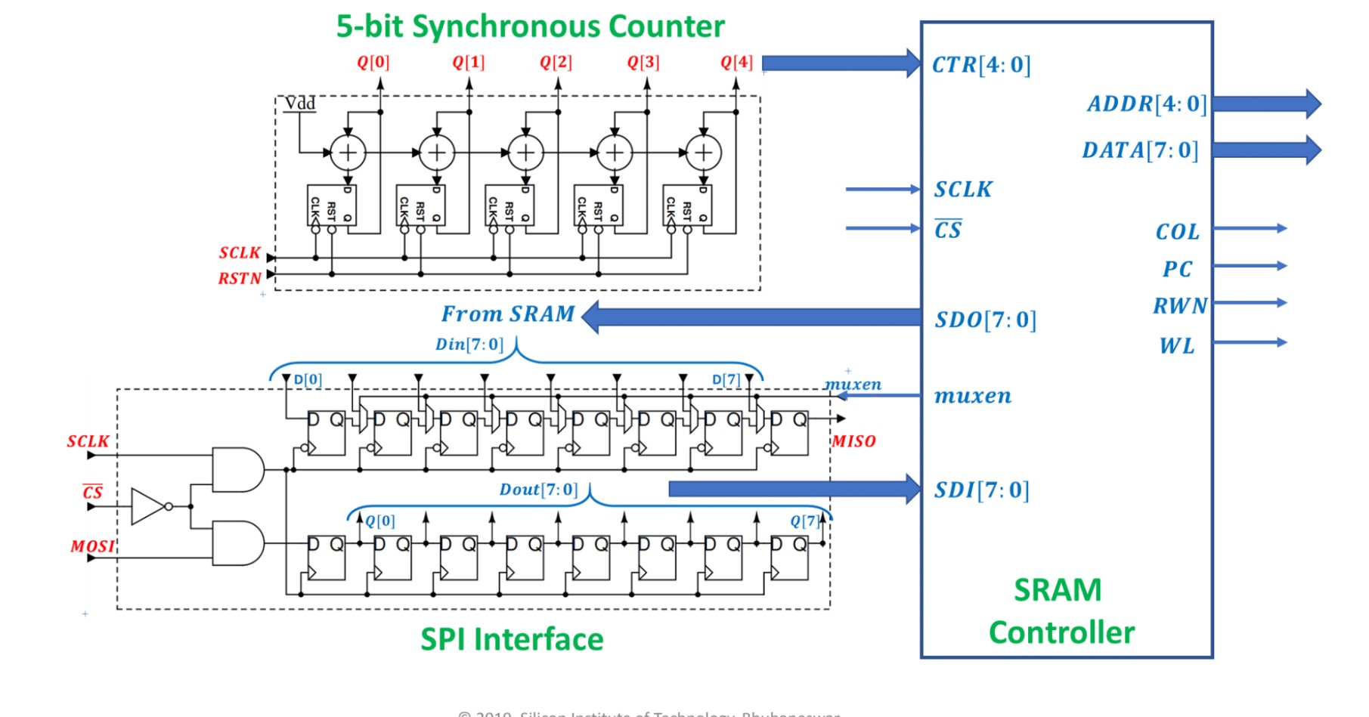 Fig4. Block diagram of SPI accessible SRAM

3. COMPONENTS

1. SPI interface

The SPI Interface consists of Serial In Parallel out and Parallel In Serial out Shift Registers. Shifting out the data in the positive edge/negative edge of the clock pulse. MOSI which is one of the signals generated by the shift register in the Master represents the data we give in as the input to the 32-bit SRAM in the write cycle. Similarly, in the Read cycle we retrieve the stored data in the SRAM though the MISO line using the SPI bus.

We have used two shift registers which are parallel to each other. The upper 8-bit Shift Registers are made up using the D-Flip-flops’ and Mux, through which the shifted data is taken out. The lower 8-bit Shift Register is through which the data is given as input to the SRAM and the output is received using the upper 8-bit Shift Register which is the MISO or the shifted SRAM output. 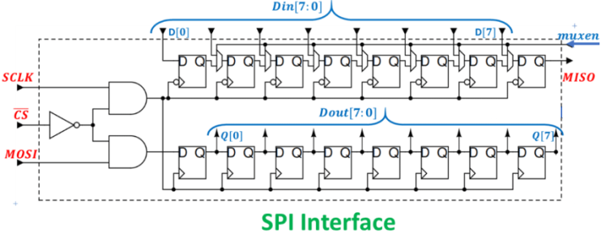

Fig5. SPI interface

2. 5bit-Synchronous COUNTER
A 5-bit synchronous negative edge triggered counter was designed to count the 16 clock cycles during which the reading and writing operations were performed on SRAM. the counter can count from (0-31) that is 16 cycles for read and 16 cycles for write. The counter is mainly made up using D-Flip-flop and Half Adder. The Half Adder is used here to add 2-bits and give an output and a carry value.The external clock signal is connected to the clock input of every individual flip-flop within the counter so that all of the flip flops are clocked together simultaneously.
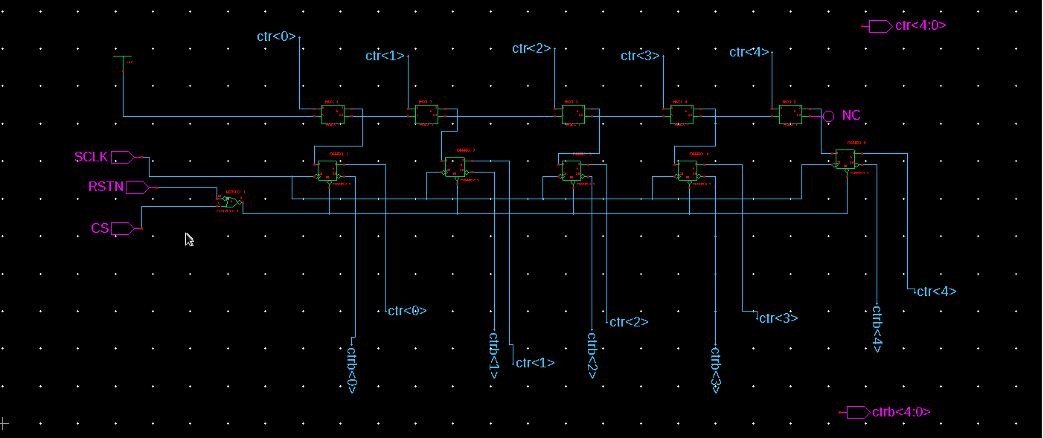
Fig6: 5 bit counter

Shift Register
Two 8-bit shift registers were designed to write or read data from the SRAM. Depending on the value of muxen signal generated by the controller one of the shift register which is negative edge triggered latches the values (muxen=high) or acts as a serial in -serial out shift register (muxen=low) during reading operation. And the other one is positive edge triggered, acts as a serial in parallel out shift register which shifts the data loaded to the controller as MOSI signal during write operation. The two shift registers are negative and positive edge triggered so as to satisfy the SPI mode 3 (i.e. Sampling on rising edge and data out on falling edge with respect to the master).
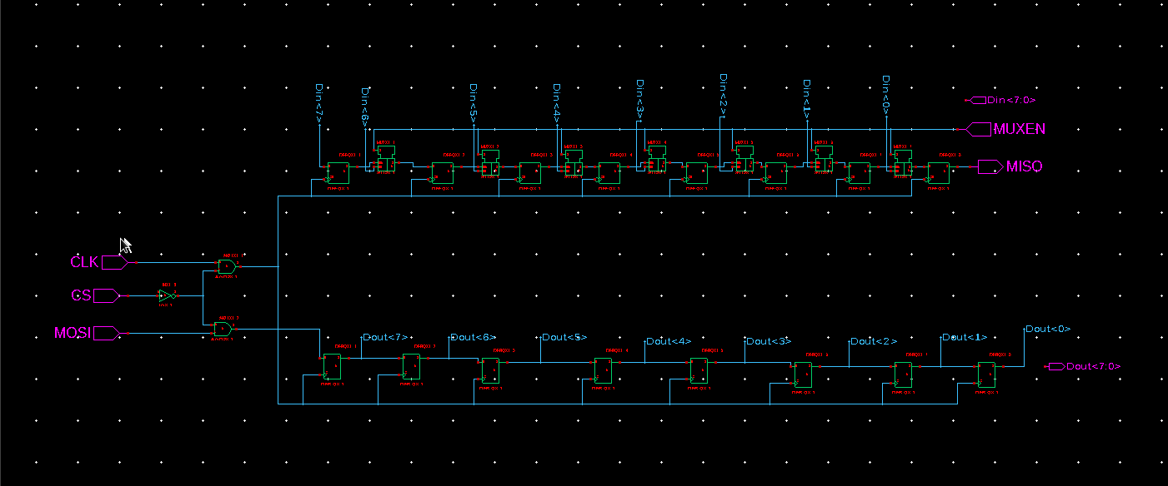
Fig7. Shift register

4. SRAM Controller

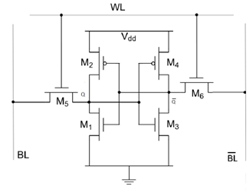

Fig12. SRAM circuit
It is a type of semiconductor memory that uses bistable latching circuitry to store each bit.SRAM is faster and more reliable.6T SRAM M2 M1 and M4 M3 are two inverter connected back to back. M5 and M6 are the access transistor used to access the BL lines for read and write operation. WL =1, M5 and M6 transistor ON we can access input and output. WL=0 the access are lost the memory will be in hold state. BL and BL bar act as input line when we have to write but BL and BL bar act as output line when we have to read from the memory.
1. READ OPERATION
Let output Q=1, Q bar=0, then WL=1 make the M5 and M6 transistor ON. We can use the BL and BL bar. When precharge capacitor at M6= VDD then BL bar voltage decreases hence the output Q bar is 1.
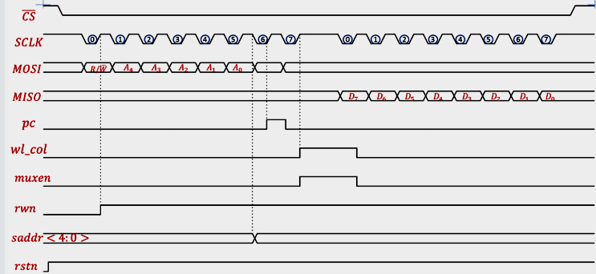 Fig13. Read operation for SRAM
- WRITE OPERATION
When Q=0, Q bar=1 then WL=1 because we have access the BL and BL bar lines. Forcefully BL bar to ground as the voltage decreases M2 and M1 affected. Since V<Vth of M1. If M1 OFF then M4 ON then Q=1 here Q=0 changes to Q=1 forcing BL bar to ground. There would be voltage difference current will flow voltage decreases.
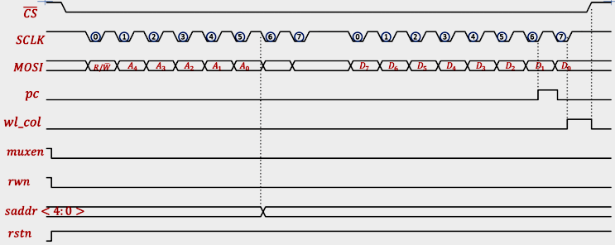 Fig14.Write operation for SRAM
RESULT AND DISCUSSION
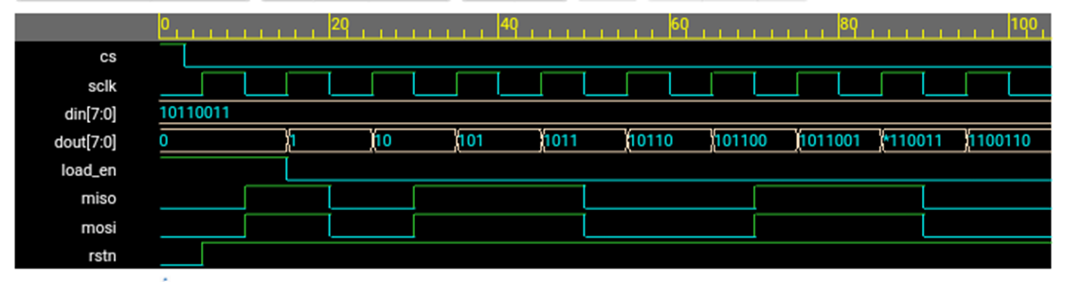
Fig15. Simulation result

Codes for Project
//Read data from SRAM
always @(negedge getsclk or negedge rstn)
begin
if(~rstn)
regint <= 8’h00;
else if ( load_en )
regint <= din;
else
regint <= regint << 1;
end
assign miso = regint[7];

//write data to SRAM
always @ ( posedge getsclk or negedge rstn )
begin
if (~rstn)
dout <= 8’h00;
else
begin
dout [0] <= mosi;
dout [7:1] <= dout [6:0];
end
end
endmodule

